Operating System Concepts

COP4610.02

Mini Project 1

Noah Baldwin

Cody Carroll

Paul Teleweck

|  |  |  |  |  |
| --- | --- | --- | --- | --- |
| Participants name | Code section | Report Section | Documentation Sec | Presentation Sec |
| Noah Baldwin | 33.33% | 33.34% | 33.33% | 33.3% |
| Cody Carroll | 33.33% | 33.33% | 33.34% | 33.3% |
| Paul Teleweck | 33.34% | 33.33% | 33.33% | 33.3% |

1. Created a user program within “user” called howmanysys.c

* Added function to print number of system calls. 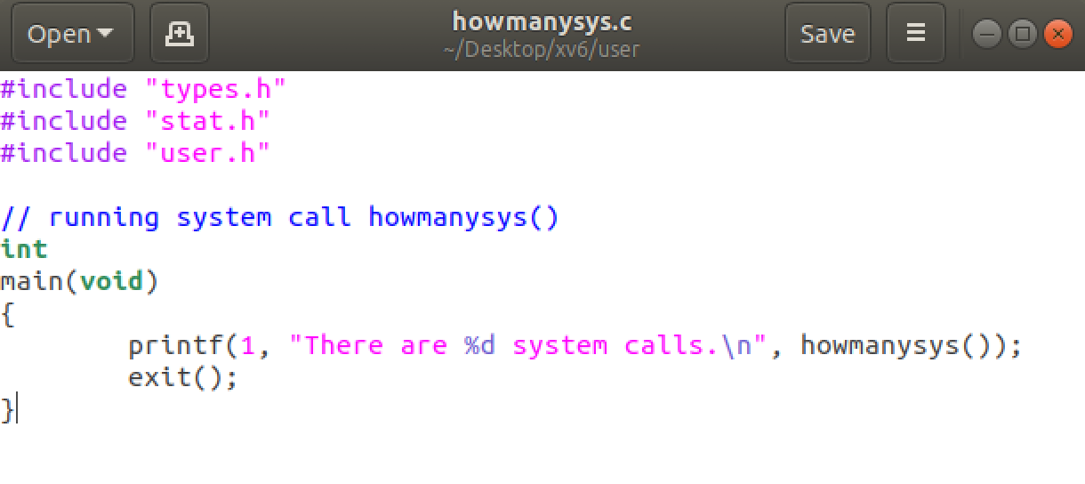

1. Add #define statement in syscall.h to add howmanysys into system calls.

* Create a system call number for howmanysy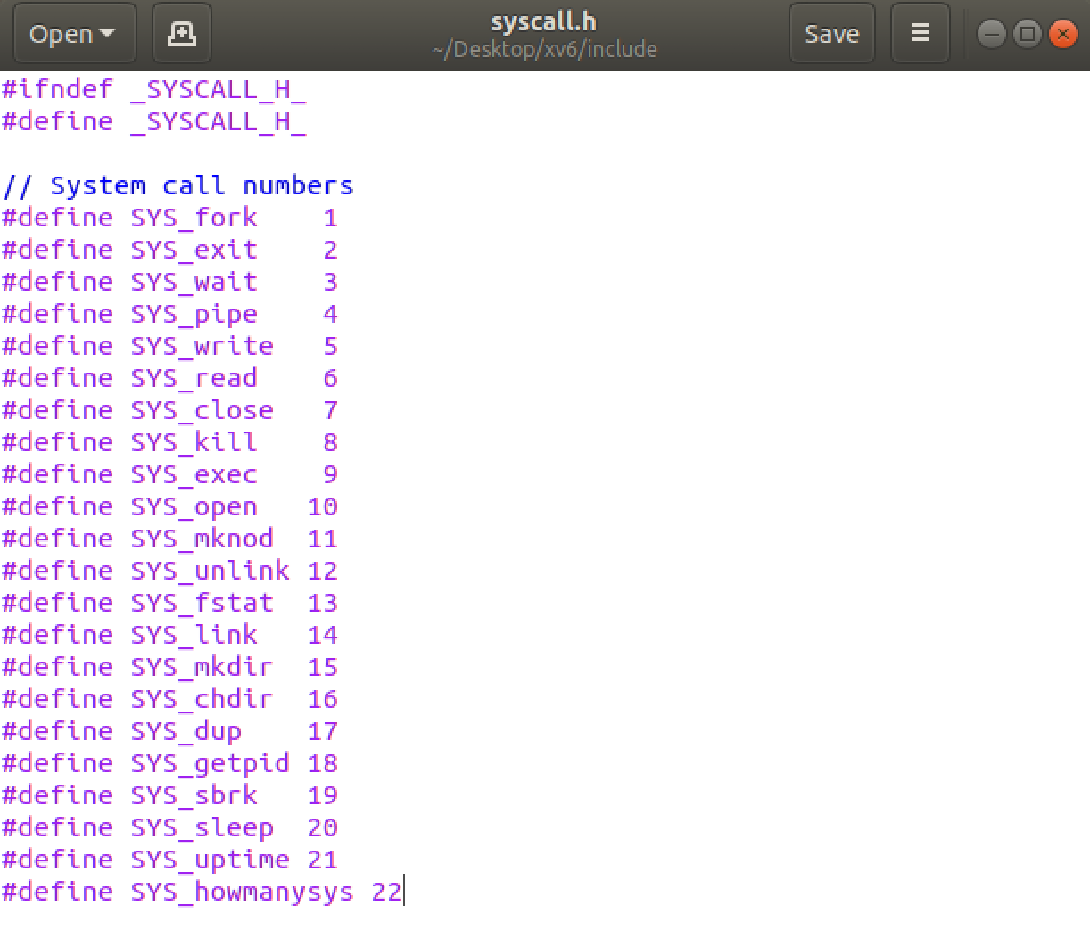

1. Add [sys_howmanysys] sys_howmanysys, inside the file syscall.c.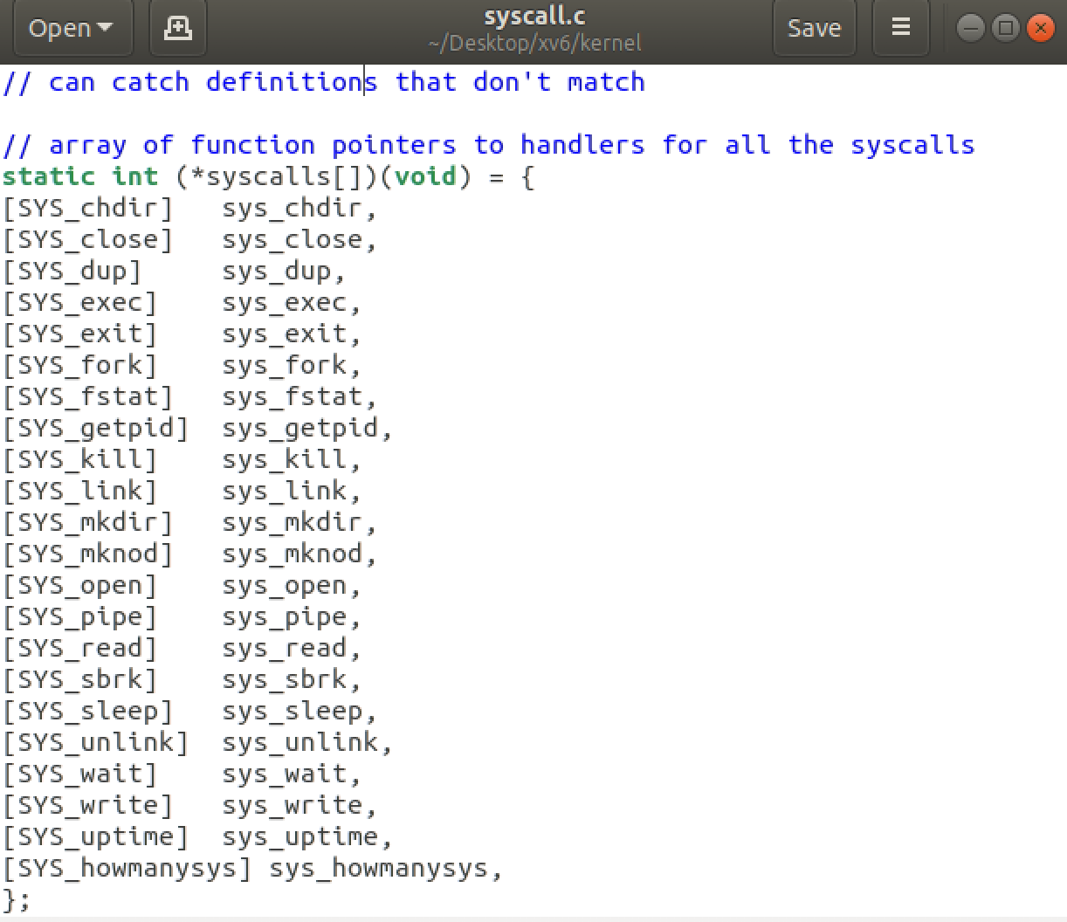
2. Add int howmanysys(void); to the file, sysfunc.h.

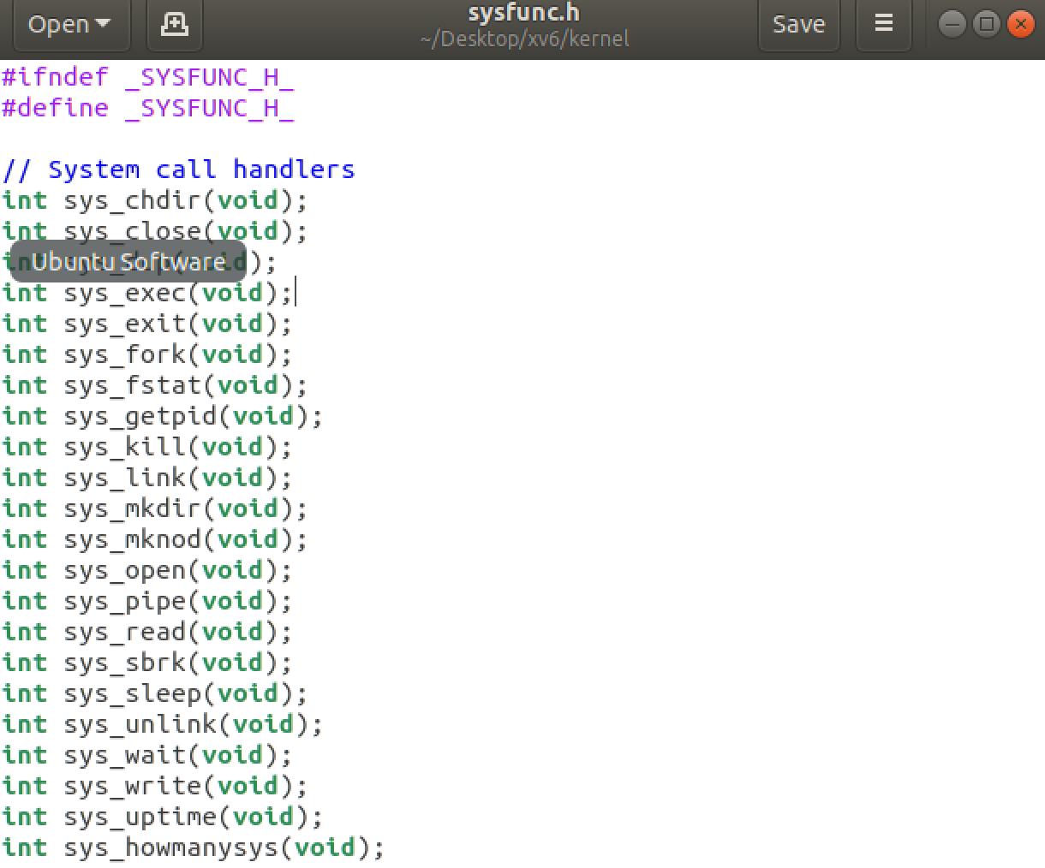

1. Add sys_howmanysys function inside sysproc.c

* Verifies syscall number is valid and calls appropriate handler. Called++ increments with every system call.

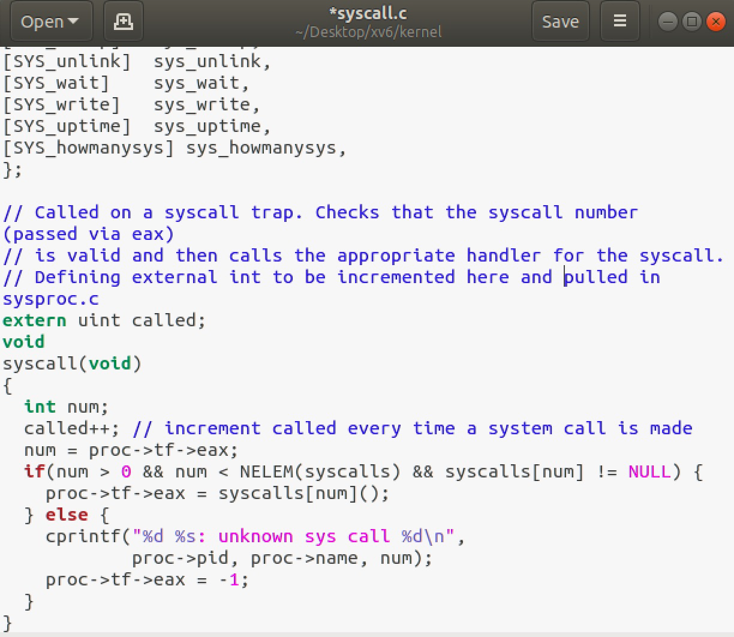

* Initializes the external integer from syscall.c at 0 and returns that integer through the howmanysys() function.

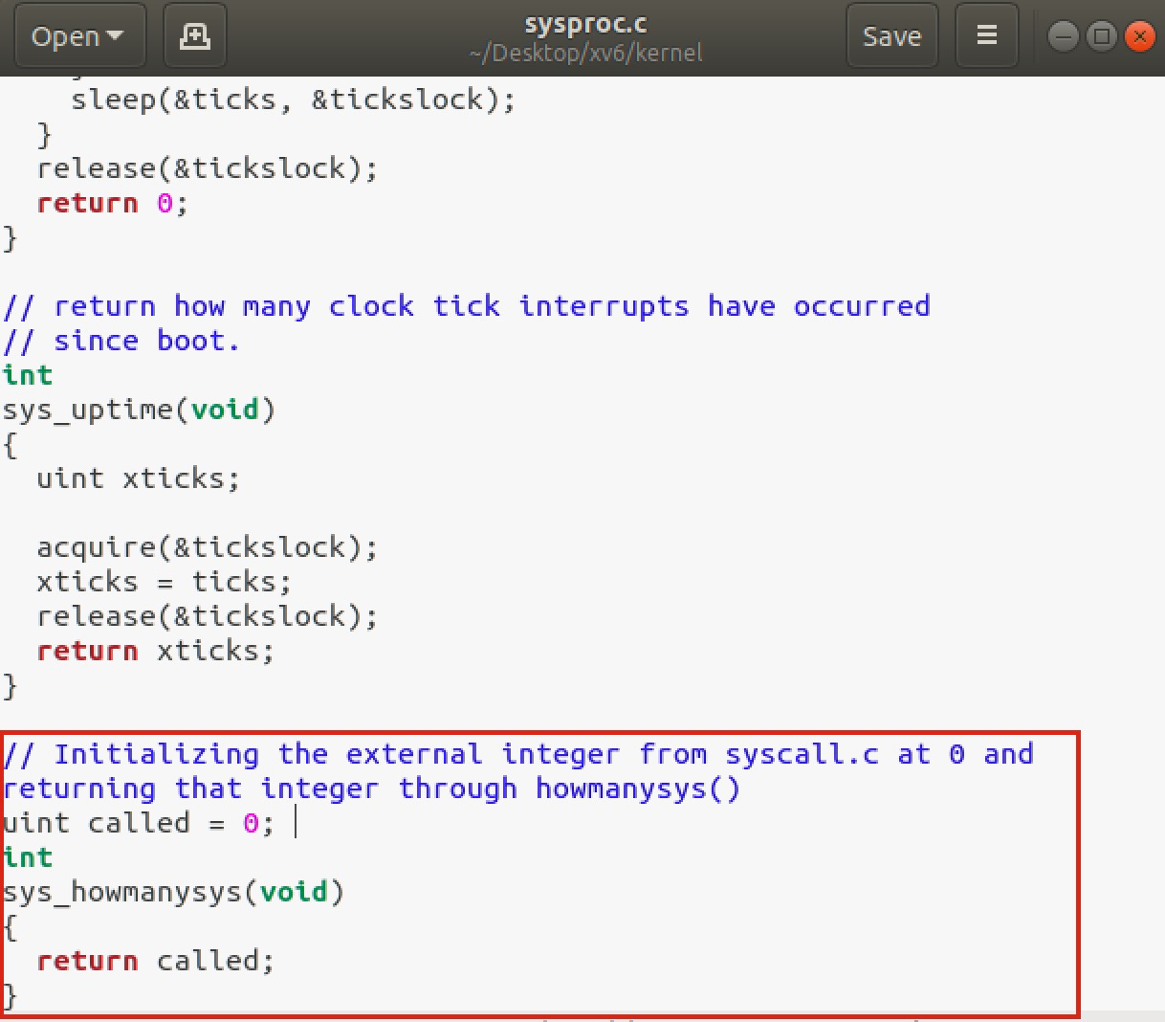

1. In the file, usys.s, we added the system call, SYSCALL(howmanysys).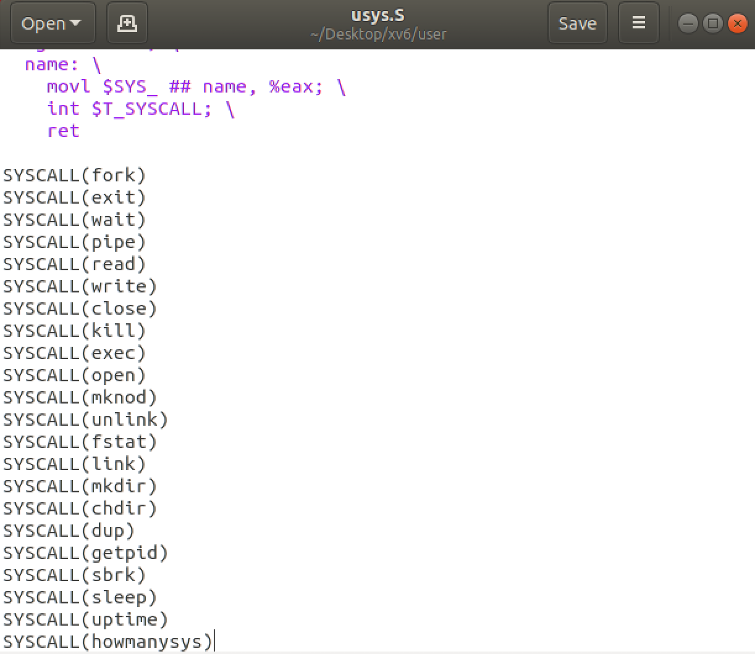
2. In the file, user.h we add the value, int howmanysys.

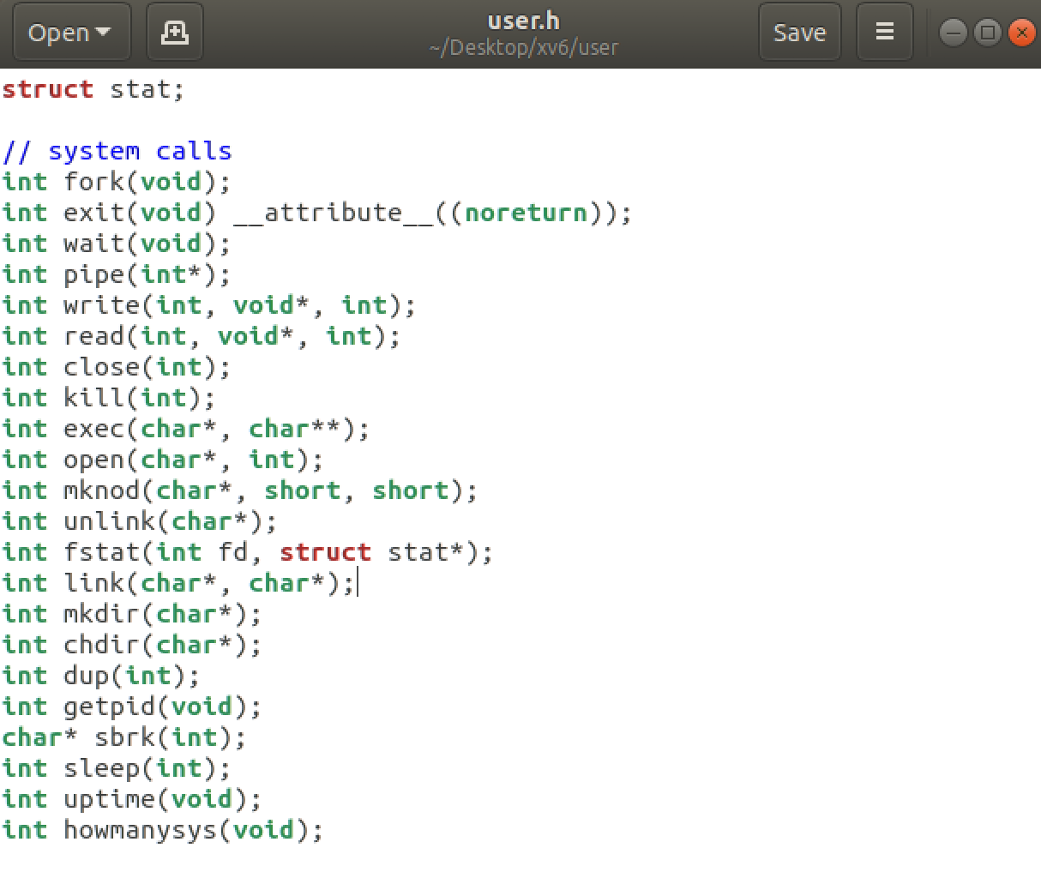

1. Add the user file howmanysys to the file, makefile.mk.

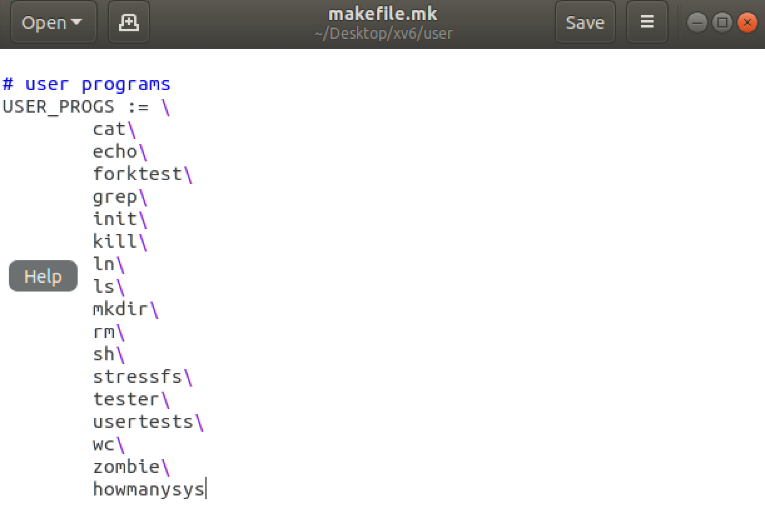

1. Makefile

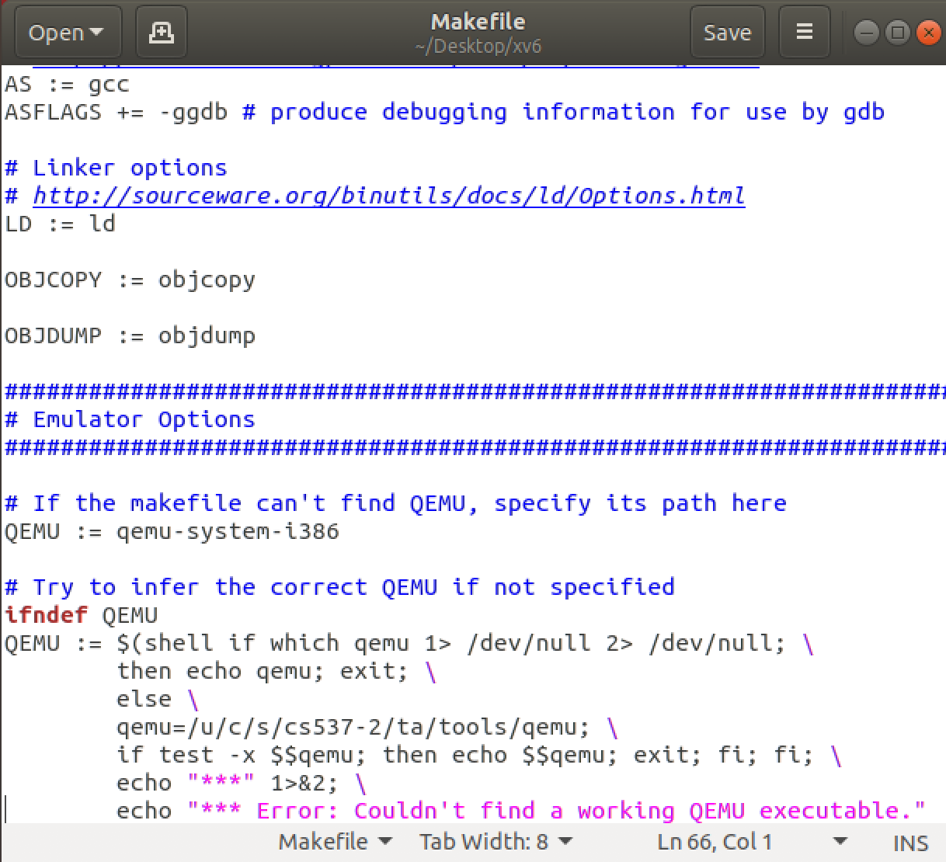

1. Output